## ****What are the different types of Machine Learning?****

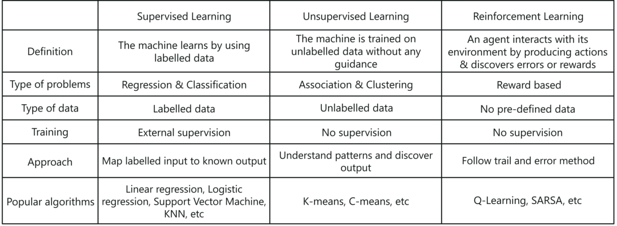

* **Explain Classification and Regression?**

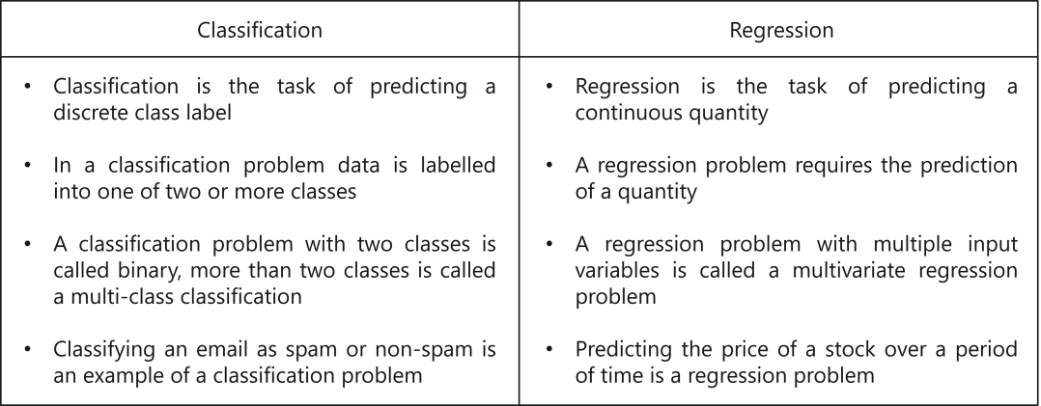

* **What is linear regression?**
* A linear regression is a linear approximation of a causal relationship between two or more variables.
* It falls under the supervised machine learning algorithms.
* **What is process of carrying out a linear regression?**
* Get sample data
* Design a model that works on that sample
* Make predictions for the whole population
* **How do you represent a simple linear regression?**
* Y = b0 +b1 x1 + e
* Y – dependent variable
* X1 – independent variable
* e – Error term = Y – Y(hat)
* **What is the difference between correlation and regression?**
* Correlation does not apply causation (the relationship between cause and effect). Regression is done to understand the impact of independent variable on the dependent variable.
* Correlation is symmetric regrading both the variables p(x,y) = p(y,x). Regression is one way.
* Correlation does not capture the direction of causal relationship. Regression captures the cause and effect.
* **What are the columns in the coefficient table?**
* The coefficient table contains the variable name, coefficient, standard error and p-value.
* **What is standard error?**
* Standard error shows the accuracy for each variable
* **What is p-value?**
* The p-value shows the significance of the variable. It tells us if the variable is useful or not.
* The H0 is coefficient = 0 and the H1 is coefficient ≠ 0
* If p-value < 0.05 (in most of the cases) we reject H0
* **What is OLS?**
* OLS stands for ordinary least square
* It measures the error between the actual Y and predicted Y
* Lower the error, better is the model
* **What are the other regression methods?**
* Generalized least squares
* Maximum likelihood estimates
* Bayesian regression
* Kernel regression
* Gaussian regression
* **What is TSS, ESS and RSS?**
* TSS stands for Total Sum of Squares. It measures the total variability (lack of consistency or fixed pattern).
* TSS = ∑(y – y(mean))2
* ESS stands for Explained Sum of Squares. It measures the variability that is explained.
* ESS = ∑(y(pred) – y(mean))2
* RSS stands for Residual Sum of Squares. It measures the difference between the observed Y and predicted Y.
* RSS = ∑(y – y(pred))2
* **What is the relationship between TSS, ESS and RSS?**
* TSS = ESS + RSS
* Total variability = Explained variability + Unexplained variability
* **What is R-Squared?**
* R-Squared is also known as goodness of fit
* Smaller the RSS, better is the model
* R-Sq = ESS / TSS = 1 – (RSS / TSS)
* R-Squared takes a value between 0 and 1.
* If R-Sq = 0 then the model does not explain any variability
* If R-Sq = 1 then the model explains entire variability
* **What is adjusted R-Squared?**
* Adjusted R-Squared is a step on R-Squared and adjusts for the number of variables included in the model
* As we add more variables the explanatory power of the model may increase.
* Adjusted R-Squared penalizes the model for the number of variables that are used in the model.
* **What is the relationship between R-Squared and Adjusted R-Squared?**
* Adj R-Sq is always lower than the R-Sq
* Adj R-Sq = 1 – ((1-RSq) * (n-1) / (n-p-1))
* Where n is the number of observations and p is the number of variables
* **What happens when we add a variable and it increases the R-Sq but decreases the Adj R-Sq?**
* The variable can be omitted since it holds no predictive power
* We should also look at the p-value of the added variable and confirm our decision
* **What is feature selection?**
* It is a method to simplify the model and improves the speed
* It is done to avoid too many features
* p-value in regression coefficient table can be used to drop insignificant variables
* **What is feature scaling?**
* Different variables have different magnitude
* Feature scaling is done to bring the variables to the same magnitude
* Standardization is one of the methods used for feature scaling
* **What is standardization?**
* It is also called normalization
* X (std) = (x – µ) / σ
* Regardless of the data we will get data with mean 0 and standard deviation of 1
* **What is the interpretation of the weights?**
* In ML coefficients are called weights.
* A positive weight shows that as feature increases in value, so does Y
* A negative weight shows that as feature decreases in value, so does Y
* **What is the difference between overfitting and underfitting?**
* Underfitting happens when the model has not captured the underlying logic of the data.
* Overfitting happens when the model has focused too much on the training dataset that it cannot understand test dataset
* **How to identify if the model is overfitting or underfitting?**
* Underfit model performs bad (low accuracy) on training and bad (low accuracy) on test.
* Overfit model performs good (high accuracy) on training and bad (low accuracy) on test.
* A good model performs good (high accuracy) on training and good (high accuracy) on test.
* **What is multiple linear regression?**
* In multiple linear regression that are more than one predictor.
* Good models require multiple independent variables in order to address the higher complexity of the problem.
* Y = b0 +b1 x1 + b2 x2 + … + bk xk + e
* **What are the assumptions of linear regression?**
* Linearity
* No endogeneity
* Normality and homoscedasticity
* No autocorrelation
* No multi-collinearity
* **What happens if the linear regression violates any of its assumptions?**
* The biggest mistake you can make is to perform a regression that violates one of its assumptions.
* If the regression assumptions are violated, then performing regression analysis will yield incorrect results.
* **What does linearity mean?**
* It means a linear relationship
* To check if there is linear relationship between x and y the simplest thing to do is plot a scatter plot between x and y
* **What are the fixes of linearity?**
* If linearity assumption is violated, then we can use non-linear regression
* We can also transform the x (exponential transformation / log transformation)
* **What does no endogeneity mean?**
* No endogeneity means no relationship between x and ε
* It may be because we have omitted an important predictor from the model
* **What is omitted variable bias?**
* If the modeler forgets to include an important predictor in the model
* It may lead to counter-intuitive coefficient signs
* Once the important variable is included rest of the coefficients fall into place
* **What is the assumption of normality?**
* It means the normal distribution of the error term
* The mean of the residuals should be zero
* The standard deviation of the residuals should be constant
* **What is the assumption of homoscedasticity?**
* In simple terms it means the equal variance
* There is no relationship between the error term and the predicted Y
* **How to prevent heteroscedasticity?**
* It may be due to outliers
* It may be due to omitted variable bias
* Log transformation
* **What does autocorrelation mean?**
* It is common in time series modeling
* It means that Y(t) is dependent on historical values, Y(t-1) or Y(t-2) or … Y(t-k)
* **How to detect autocorrelation?**
* DW ( **Durbin Watson** ) test is used to detect autocorrelation
* If DW test statistics is less than 1 then there is strong autocorrelation
* If DW test statistics is close to 2 then there is no autocorrelation
* If DW test statistics is more then 3 then there is strong autocorrelation
* **What are the remedies to remove autocorrelation?**
* There is no remedy in linear regression
* The modelers can try different models like AR, MA, ARMA or ARIMA
* **What does multicollinearity mean?**
* When two or more variables have high correlation
* If there is perfect multicollinearity then standard error will be infinite
* Imperfect multicollinearity means that the correlation is slightly less than 1 or slightly more than -1. However imperfect multicollinearity also causes serious issues in the model
* **What are the fixes of multicollinearity?**
* Find the correlation between each pair of independent variables
* If two variables are highly correlated, then either drop one of them or transform them into a single variable
* **What is VIF? How do you calculate it?**
* Variance Inflation Factor (VIF) is used to check the presence of multicollinearity in a dataset.
* **What are the disadvantages of the linear model?**
* Linear regression is sensitive to outliers which may affect the result.
* Over-fitting
* Under-fitting
* **How to find RMSE and MSE?**
* **Answer???**

### What is the importance of the F-test in a linear model?

* The F-test is a crucial one in the sense that it tests the goodness of the model. When you reiterate the model to improve the accuracy with the changes, the F-test proves its utility in understanding the effect of the overall regression.

### How do you interpret a Q-Q plot in a linear regression model?

* As the name suggests, the Q-Q plot is a graphical plotting of the quantiles of two distributions with respect to each other. In other words, you plot quantiles against quantiles.
* Whenever you interpret a Q-Q plot, you should concentrate on the ‘y = x’ line. You also call it the 45-degree line in statistics. It entails that each of your distributions has the same quantiles. In case you witness a deviation from this line, one of the distributions could be skewed when compared to the other.
* **Pearson Vs Spearman correlation**
* **Pearson:** - The Pearson correlation evaluates the linear relationship between two continuous variables. A relationship is linear when a change in one variable is associated with a proportional change in the other variable.
* **Spearman**: - The Spearman correlation evaluates the monotonic relationship between two continuous or ordinal variables. In a monotonic relationship, the variables tend to change together, but not necessarily at a constant rate. The Spearman correlation coefficient is based on the ranked values for each variable rather than the raw data.
* **Graph**
* **Bar graphs** to show numbers that are independent of each other.
* **Pie charts** to show you how a whole is divided into different parts.
* **Line graphs** show you how numbers have changed over time.
* **Cartesian graphs** have numbers on both axes, which therefore allow you to show how changes in one thing affect another. These are widely used in mathematics, and particularly in [**algebra**](https://www.skillsyouneed.com/num/algebra-introduction.html).